

ASSIGNMENT-7

# PYTHON

# **NAME : MADA SRAGVIN KUMAR**

# **MIS NO : 112315097**

# **GROUP : 3**

**YEAR : 2**

**SECTION : A**

# **1:**

def sum(a,b):

return a+b

a=int(input("enter the number: "))

b=int(input("enter the number: "))

print(sum(a,b))

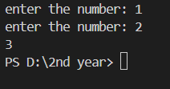

# **2:**

def encription(a):

k=str()

for i in a:

if i.islower():

k=k+chr(97+((ord(i)-3-97)%26))

elif i.isupper():

k=k+chr(65+((ord(i)-3-65)%26))

else:

k=k+i

return k

a=input("enter the string: ")

c=encription(a)

print(c)

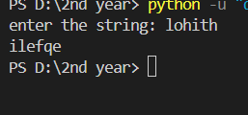

# **3:**

def fun(a, d):

k = ""

for i in a:

if i in d:

k += d[i]

else:

k += i

return k

a = input("Enter the text: ")

d = dict(zip(

[chr(i) for i in range(97, 123)],

[chr(97 + ((i - 97 + 3) % 26)) for i in range(97, 123)]

))

k = dict(zip(

[chr(i) for i in range(65, 91)],

[chr(65 + ((i - 65 + 3) % 26)) for i in range(65, 91)]

))

d.update(k)

print(fun(a, d))



# **4:**

a=input("enter the string: ")

b=input("enter the string: ")

print(a+b)

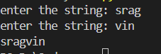

# **5:**

def fun():

d={}

d={k:k*k for k in range(1,21)}

return d

print(fun())



# **6:**

def fun():

l=[k*k for k in range(1,21)]

for i in range(0,5):

print(l[i])

fun()

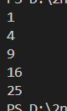

# **7:**

def fibonacci(n):

l=[]

l.append(0)

l.append(1)

for i in range(2,n):

l.append(l[i-1]+l[i-2])

return l[n-1]

a=int(input("enter the element u eant to search: "))

print(fibonacci(a))



# **8:**

def fun():

a=1

b=8.4

c="str"

a=3

print(fun.__code__.co_nlocals)

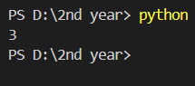

# **9:**

def fun():

global a

a=10

a=20

fun()

print(a)

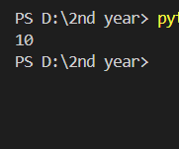

# 

# **10(1):**

def append_item(item,item_list=[]):

item_list.append(item)

return item_list

n=int(input("enter the number: "))

for i in range(0,n):

print(append_item(1))

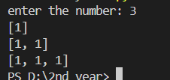

# **10(2):**

Although we are using the argument item_list again as [] ,but the list gets modifies during the function calls and it will update itself during those calls

To avoid this we use none function as default.it's not like we are creating a new

Argument item_list we are using the past item_list only.

# **10(3):**

def append_item(item,item_list=None):

if item_list==None:

item_list=[]

item_list.append(item)

return item_list

n=int(input("enter the number: "))

for i in range(0,n):

print(append_item(1))

